Wednesday 17th June 2026

Dear Parents of Year 5

Year 6 residential visits to Hooke Court
We are delighted to share that we have arranged two fantastic residential visits for pupils moving up to year 6 in September. The visits will take place at Hooke Court residential centre in Dorset. To support the children with both academic learning and their personal development, the two residential visits have been carefully timed and designed to offer distinct purposes that will help the children to thrive in year 6 and beyond as they transition to secondary school.
The first residential visit will take place in the autumn term from Wednesday 23rd September to Wednesday 25th September 2026. This trip is highly curriculum-focused and designed to bring our history topic ‘World War’ to life. By immersing themselves in a World War 1 & 2 themed experience, the children will gain a deep, hands-on understanding of the era that simply cannot be replicated in the classroom.

Below is an outline of the exciting activities that the children will take part in.

WW2 Evacuee experiences
As part of this experience, the children will experience first-hand what it was like for children during WW2 to be evacuated to rural areas of Britain. They will learn what it was like to go to school during the war and will write letters home with dip pen and ink. The children will also take part in wartime cooking where they will learn about food and rationing, they will handle real money from the period and will use recipes from the war to prepare and eat. The children will find out what it was like to shelter from an air raid in the Anderson shelter and will take part in wartime drills.

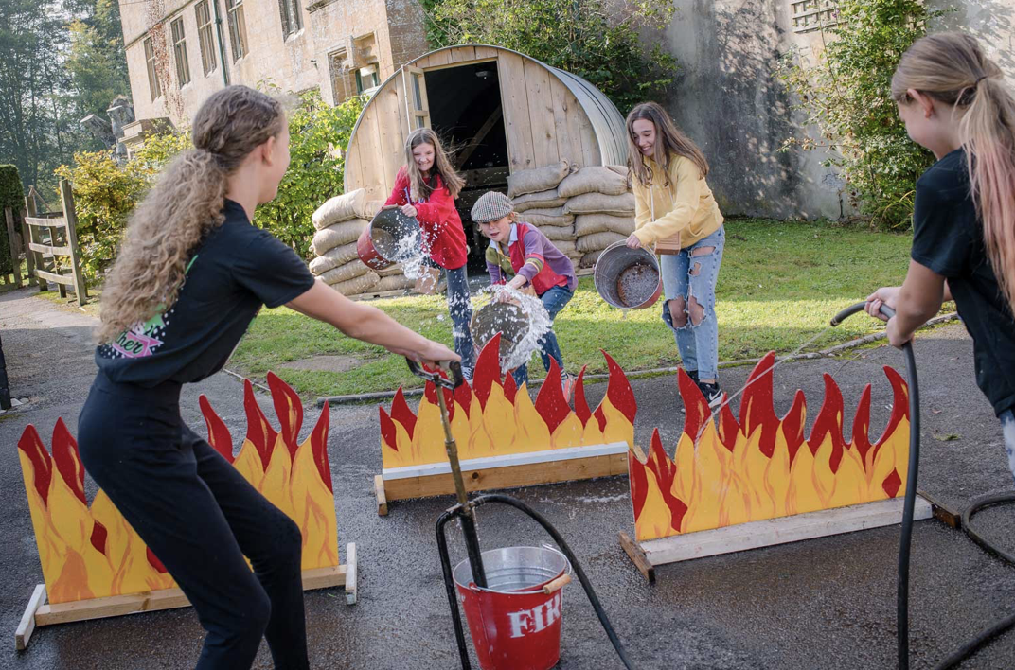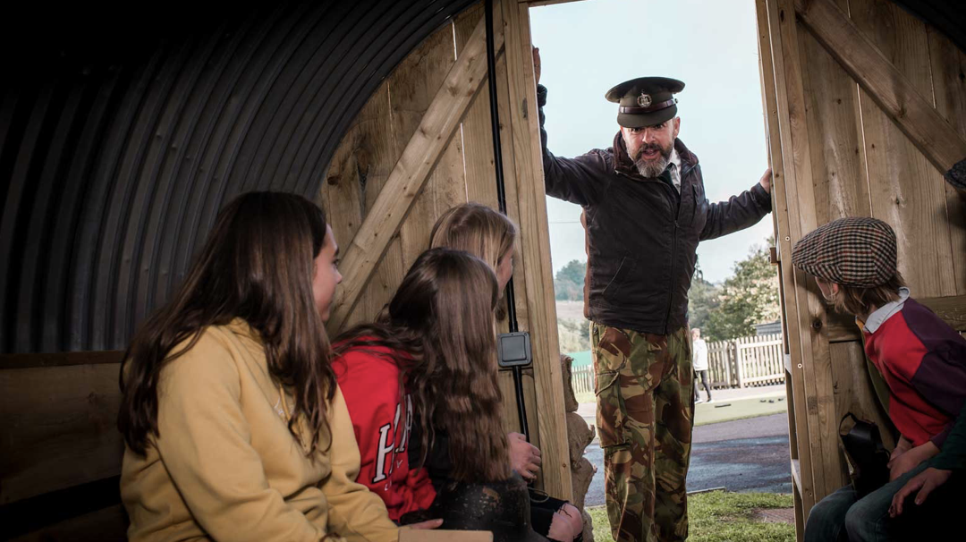

VE day party and games
In the evening, the children will join in a VE party where they will celebrate the end of the war in Europe by enjoying a meal from the period and listening to Winston Churchill and the music of Glen Miller. After dinner, the children will continue the celebrations by playing favourite games from the era.

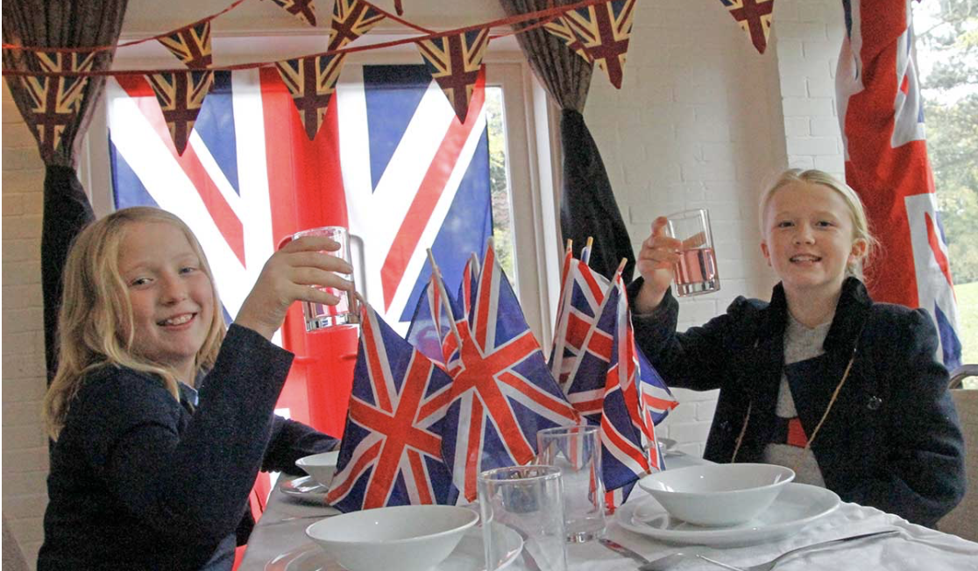

WW1 and WW2 battle experiences including life in the Trenches

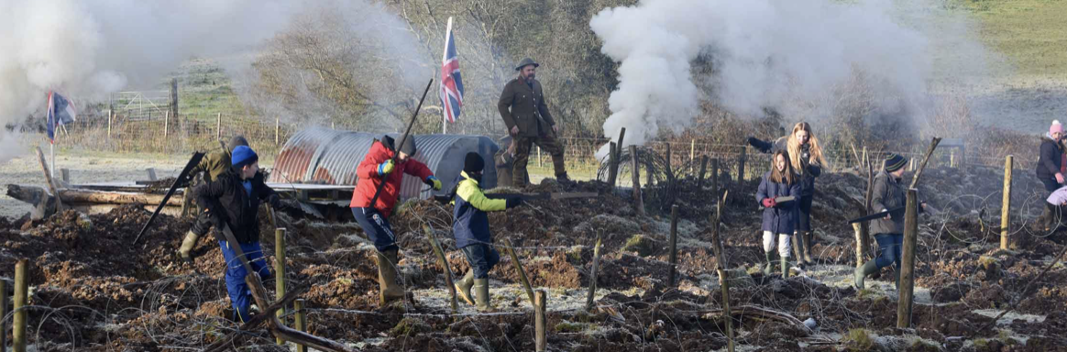

For this activity, the children will march in formation to the ‘Front’ and make their way through the trenches. They will be set to work with filling sand bags and placing them in position in the trench. They will practise scaling the ladders and will partake in ‘tea and wads’ before going ‘over the top’.

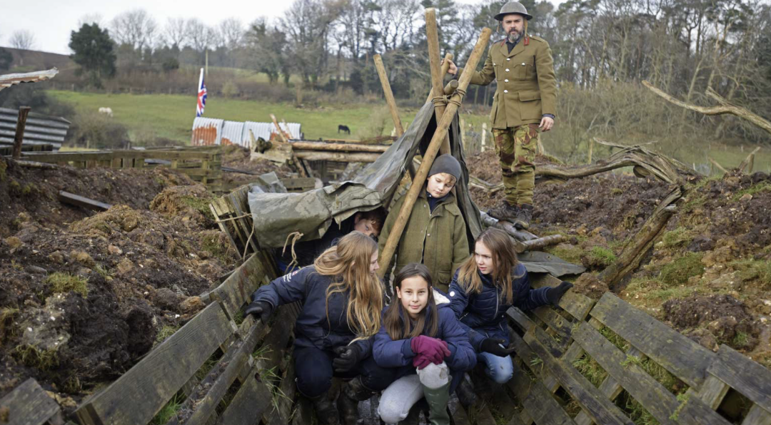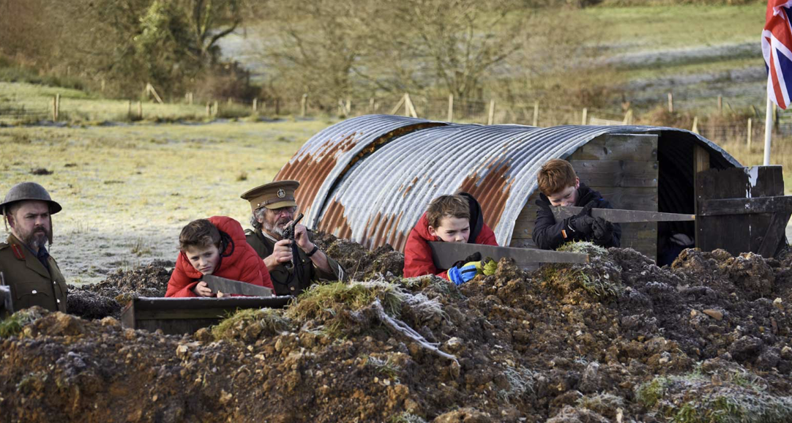

Campfire in the Trenches
In the evening, the children will enjoy listening to stories and songs around a campfire in the trenches.

May 17th - 19th 2027: Outdoor Adventure and Secondary Transition
Our second residential will take place toward the end of the school year. The focus of this trip shifts completely toward outdoor adventure, team-building, and resilience. As the children prepare for the big leap to secondary school, these activities will help them strengthen existing bonds, make new friends, build confidence, and develop vital teamwork skills to ensure a smooth transition.
The total cost of both visits is £500 per person, and this includes the cost of the coach, accommodation, food and activities for the duration of the visits. Payments for these visits can be made via the Arbor payment system and are available now. If you would like your child to go on the residential visits, please pay a £80 non-refundable deposit by Friday 26th June 2026. Following payment of the deposit, you will be able to make payments in instalments if needed and the full cost of the trips will need to be paid by Friday 30th April 2027 .

An outline of a payment schedule is as follows:

Residential 23rd-25th September 2026

Initial non-refundable deposit of £80 | By Friday 26th June 2026
Second payment £85 | By Friday 30th July 2026
Final Payment of £85 | By Friday 10th September 2026.
Total = £250

Residential 17th-19th May2027

Initial non-refundable deposit of £80 | By Friday 29th January 2027
Second payment £85 | By Thursday 25th March 2027
Final Payment of £85 | By Friday 30th April 2027.
Total = £250

*Please note that for residential visits, cancellation charges will apply, and the school cannot offer a refund once the final payment to the venue has been paid.

Arrangements for September residential:
The coach will be collecting the children from Bisham Abbey sports centre on Wednesday 23rd September and the children will need to be dropped off there between 7:45am and 8:00am ready to depart at 8:15am promptly. The children will be returning back to Bisham Abbey sports centre on Friday 25th September and will need to be collected from there. We are anticipating that they will arrive back between 15:45 -16:00.

The children will need to be provided with a packed lunch and water bottle for the Monday, but all other food and refreshments will be provided. If your child will require any medication, we request that the instructions for administering medication are given to the school office by Monday 21st September 2026.

Arrangements for the residential visit in May will be shared nearer the time.

Please find below the final packing list for the visit to Hooke Court.

Packing list for Hooke Court
Children should arrive wearing their own clothes and trainers
Towel
Underwear/socks for each day plus spare sets
T-shirts Trousers/Shorts/leggings and or joggers
Jumper/Fleece
Indoor Shoes/slippers/ sliders
Spare pair of trainers if trainers get wet
Wellies (if you have) if the weather has been wet for the trenches
Toiletries/Wash kit and Sun Cream/Sun Hat

Pyjamas
Rain Coat

Story Book
Large plastic bag for dirty clothes
Named Water bottle
Favourite toy and reading book

Please Do Not Pack
Make-up, perfume
Aerosol deodorants
Sweets/other foods
Electronics/i-pads/phones Jeans
Torch

We will be holding a virtual meeting to provide details about the residentials on Wednesday 24th June 2026 at 7:30pm. Please join the online meeting using the information below.

Topic: Year 6 June 2026 Hooke Court Meeting

Zoom Meeting link:
https://us06web.zoom.us/j/82185322486?pwd=QE05UNGhG1SaS7EIVbbv6liqna39ab.1

Please do get in touch with the school office if you have any questions regarding the trip to Hooke Court.

Yours sincerely
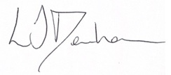
Mrs Laura Denham
Head of School

